Lab report:
Parking sensor
Wednesday 14 October 2021

1 Abstract
The purpose of this lab was to reversely engineer a parking sensor system. With an oscilloscope the characteristics of the wave used by the system was monitored and observed. By using varying distances and setups of the sensors and their surroundings, the limitations and capabilities of the system could be observed.

2 Introduction

2.1 Background
This report aims to get an increased understanding of reverse engineering with delimitation to assess the practical function and, thus, use of commercial parking sensors. For an efficient and well-executed implementation, a certain familiarity and handling of the measurement instrument oscilloscope, which presents all data, is required.

2.2 Parking sensors

2.2.1 Transmitter and receiver
The purpose of parking sensors is to detect and warn the driver of a vehicle of nearing objects, including people, and thereby facilitating parking. The detection system requires two sensors: one transmitting and one receiving.
The difference between the two sensors is that one transmits a signal (wave) while the other receives it after reflection with an object; the distance to it can be calculated mathematically as the speed of sound multiplied with the time it takes for the signal to travel from the transmitting sensor to the receiving one (after reflection). Note that the signal travels back and forth. Therefore, the calculated distance, given by the formula
$$Equation 1a: \\ distance \left[m\right]=speed of sound \left[m/s\right]∙time \left[s\right]$$
, is, in fact, twice the distance to the object. Thus, a factor $\frac{1}{2}$ must be included in the equation:
$$Equation 1b: \\ distance \left[m\right]=\frac{1}{2}∙speed of sound \left[m/s\right]∙time \left[s\right]$$

2.2.2 Continuous and pulse waveform
The graphical shape – a function of the time – of a signal is called a waveform, and there are typically two types: continuous and pulse. The continuous wave (CW) is of constant amplitude and frequency, for example, a sine (or sinusoidal) wave, while a pulse wave is of non-constant (asymmetric) character, where the quantity values are time dependent.

2.3 Definitions
The properties of a traveling or propagating signal wave are its wavelength, frequency (period), and propagation (phase) velocity, illustrated in below (see Figure 1):

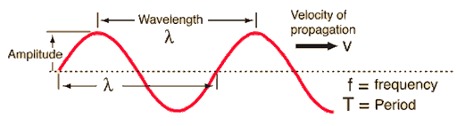
Figure 1 - Illustration of wavelength, frequency, and velocity of propagation. Source: http://hyperphysics.phy-astr.gsu.edu/hbase/Waves/imgwav/wrel1.gif

2.3.1 Wavelength
The wavelength is the distance from any given point to next, after which the shape repeats the cycle.

2.3.2 Frequency (and period)
The number of waves passing a given (fixed) point in a certain amount of time is called the wave frequency $f$. Thus, the repeating pattern can be described as the number of occurrences (oscillations) per time unit. The wave period is the time it takes to complete one cycle, and, therefore, the inverse to the frequency.
$$Equation 2: \\ f \left[Hz\right]=\frac{1}{T}$$

2.3.3 Wave speed (phase velocity)
The definition of a wave in motion is "the propagation (phase) speed $v \left[m/s\right]$ is equivalent to the wave's frequency $\left[Hz\right]$ times its wavelength $λ \left[m\right]$,” according to the general formula
$$Equation 3: \\ v=\frac{λ}{T}=f∙λ$$

2.4 Linear regression analysis
In statistics, linear regression analysis is a method to determine a function best suited to the collected data. Graphically, the regression acts like a trendline, from which on can obtain the slope coefficient. For a simple linear regression – the trendline is linear – the regression equation is
$$Equation 4: \\ y=mx+b$$
, where $y$ (vertical), a dependent quantity, is a function of $x$ (horizontal), an independent quantity, $m$ is the slope coefficient, and $b$ is the deviation (error) from the origin $\left(0,0\right)$.

2.5 Measurement errors and analysis

2.5.1 Approximation errors – relative and absolute error
An approximation error explicates the relation between the exact value $α$ and its approximation $Δα$. For example, the discrepancy for an absolute value is called relative error $\frac{Δx}{x}$. Note that the absolute error $Δx$ is defined mathematically as the difference, in absolute, between the exact value $x$ and the proximity one $\overline{x}$, in this case, the mean approximation, according to the following:
$$Δx=\left|x-\overline{x}\right|$$

2.5.2 Standard deviation
A standard deviation (SD) $σ$ measures the amount discrepancy (the error) of a set of values, projected by the formula
$$Equation 5: \\ σ=\sqrt{\frac{1}{N}\left({\left(x_{1}-μ\right)}^{2}+{\left(x_{2}-μ\right)}^{2}+…+{(x_{N}-μ)}^{2}\right)}$$
, where $x_{index}$ is every individual value, $μ$ represents the respectively mean, and $N$ represents the number of values.

2.5.3 Error analysis
The calculations of speed will contain two factors that both have relative errors. These errors will be accounted for by the following formula, where $Δ$ is the sign for error.
$$Δv=\sqrt{{\left(\frac{δv}{δf}\right)}^{2}∙{\left(∆f\right)}^{2}+{\left(\frac{δv}{δλ}\right)}^{2}∙{\left(∆λ\right)}^{2}} \\ =\left\{Wave speed definiton: v≡λ∙f\right\} \\ =\sqrt{λ^{2}∙{\left(∆f\right)}^{2}+f^{2}∙{\left(∆λ\right)}^{2}} \\ ⟹Δv=\sqrt{λ^{2}∙{\left(∆f\right)}^{2}+f^{2}∙{\left(∆λ\right)}^{2}}$$
$$Equation 6: \\ Δv=\sqrt{λ^{2}∙{\left(∆f\right)}^{2}+f^{2}∙{\left(∆λ\right)}^{2}}$$

2.5.4 Reading error
In the light of an (inaccurate) visual readout of the human eye, a reading error is a deviation from the exact indication (value) presented by an instrument. For measurement with visual reading – with the help of the human eye – the reading error is half of the minimum grading, while for digital readout, the reading error is one-half of the last digit. A discrepancy can be caused not only by human factors but also by technical ones, such as the limited resolution of a monitor or display. Including reading errors is relevant given that multiple individuals are (often) involved and the data is, thus, collected by several, who read data differently, some better than others.

2.5.5 Measurement error
A measurement error is a combination (addition) of the standard deviation and the reading error. Thus, the measurement error is used in mathematical analysis for a relatively good approximation.

3 Method

3.1 Materials
The following materials and equipment were used during the lab:
- 4 parking sensors (2 modified with BNC-connections)
- 3 sensor holders
- 1 control unit (black box with current adapter)
- 1 display (with manual)
- 1 oscilloscope
- 1 BNC-cable with resistance $\left(10→\right)$ and T-connection
- 1 long (120 cm) rail
- 1 short (20 cm) rail

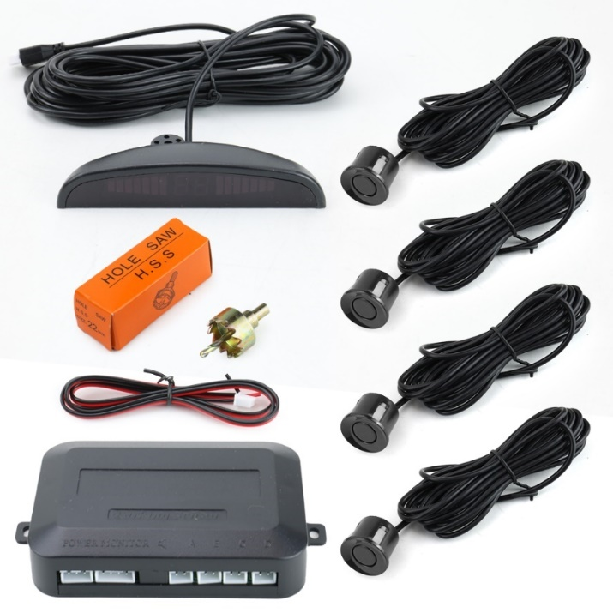
Figure 2 – The control unit and its including adapters and connections.
On the right of Figure 2 is the four sensors supplied for this lab. The box in the bottom is the control unit and on top is the display. The H.S.S hole saw in the middle is for mounting the sensors on a car and it was not used in this lab. Below in figure 3 is the T-connection.
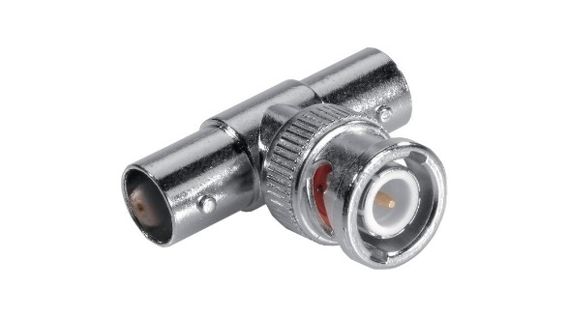
Figure 3 – A T-connection

3.2 Procedure

3.2.1 The physical principles behind parking sensors
The first part of the experimental assignment involved setting up the parking sensor system using the supplied cables and equipment so that the transmitting and receiving sensors were connected to Channel 1 (CH1) respectively Channel 2 (CH2) of the oscilloscope. The system core consists of a control unit (powered by an electrical outlet), including its network adapter and display, with four input ports, where each can connect to a parking sensor, which can transmit and/or receive a signal.
The control unit was linked to the oscilloscope using a BNC cable through a T-connection, allowing the measurement instrument to read the signal sent from the control unit to the transmitting sensor. The receiving sensor was connected directly to the second channel (CH2) of the oscilloscope. Both sensors were installed on a holding system: placing them one meter apart and facing each other on a 1,2-meter-long rail. The transmitting and receiving signals displayed respectively as a blue and yellow waveform were regulated independently - for example, to zoom, adjust the position and scale, and so forth - using the oscilloscope's controlling system.
To determine the wavelength and frequency, the receiver was physically moved closer further away from the transmitter. When moving it closer, the receiving waveform, plotted on the oscilloscope's screen, moved in sync. The frequency $\left(λ\right)$ defines as the inverse of the period $\left(T\right)$, which was determined by counting the number of squares between two peaks (maximum) or two valleys (minimum). By moving the receiver exactly one wavelength on the screen, the distance was determined, using the measurement tape, as the length the receiving sensor had moved. For improved accuracy, a mean distance was calculated by moving the receiver a certain number of wavelengths - the higher the number, the more reliable result- and then dividing the measured total length with the same number of wavelengths.
The speed of the wave $\left(v\right)$ was calculated as the product of the frequency and wavelength. After that, the mission was to recognize if the wave was continuous or pulsive by visually examining the graphs.
Eventual deviations from expected results were commented on.

3.2.2 Characterize the system and explore the limitations
The second part included the same parts as the first setup but also involved a wall.
For the second setup, the electronic connections between components remained the same as in the previous experimental part, with the exception that the sensors were, instead of facing each other, placed a few centimetres apart - in order to prevent signal interference - and also facing a wall, of which the transmitted signal was reflected.
As explained in 2.2.1, the distance to the wall represents one-half of the distance in the first setup. Five specific and precise distances from the wall to the sensors were selected: from 0,6 meters to 1,0 meters, with 10 centimetres increasing successfully. For each distance, the resulting time and signal strength (in voltage) was measured three times using the oscilloscope and, thus, consistently, counting the squares on the screen. For practical reasons, the receiver was placed on a 0,2-meter short rail to make moving it more convenient.
Eventual deviations from expected results were commented on.

4 Results

4.1 Wavelength, frequency and speed
When measuring the wavelength by counting exactly one wavelength, the result was $λ=11 mm$. However, after measuring five wavelengths and then dividing the answer with five, a more accurate result was obtained: $λ=\frac{42}{5}=8,4 mm$. Thus, this value was the one decided to be used for the rest of the lab. The measured period – by counting squares horizontally – was determined to $25 μs$ (equal to five squares), which meant that the frequency – the inverse of the period – was calculated using Equation 2 to
$$f=\frac{1}{25∙{10}^{-6}}=4,0∙{10}^{4}=40 kHz$$
Using Equation 3, the speed was accordingly
$$v=f∙λ=\left(40∙{10}^{3}\right)∙\left(8,4∙{10}^{-3} m\right)=336 m/s$$
For analysis of these results, one can use that the speed of sound in 20-degree Celsius air is known to be $\sim 340,4 m/s$.

4.2 First part errors
Since the measuring tape uses a graduation of 1 mm the reading error that should be used is 0.5mm. Because of that the value for the wavelength should be $\frac{42±0.5}{5}=8.4±0.1 mm$. For the period, the graduation on the time axis was $0.4 μs.$ Therefor the error should be $0,2 μs$ or $2∙{10}^{-7}s$. To receive the error in frequency the following formula is used
$$\frac{\text{Δ}T}{T}=\frac{\text{Δ}f}{f} ⟹\text{Δ}f=\frac{\text{Δ}T}{T}∙f=\frac{\left(2∙{10}^{-7}\right)}{25∙{10}^{-6}}∙\left(40∙{10}^{3}\right)=320Hz$$
Using Equation 6, the error of the speed $Δv$ was calculated to be
$$Δv=\sqrt{λ^{2}∙{\left(∆f\right)}^{2}+f^{2}∙{\left(∆λ\right)}^{2}} \\ =\sqrt{{\left(8.4∙{10}^{-3}\right)}^{2}∙{\left(320\right)}^{2}+{\left(4∙{10}^{4}\right)}^{2}∙{\left(1∙{10}^{-4}\right)}^{2}} \\ =4.81927 \\ ≈4.82m/s$$
Thus, the error is $Δv=±4,82 m/s$.

4.3 System characterization and limitations
From the measurements in part two with the changed distances the following data was collected.
Table 1 – Table including three measurements and the means.
Distance (meters) | Measurement 1 |  | Measurement 2 |  | Measurement 3 |  | Means
 | Time  $$\left[ms\right]$$ | Amplitude  $$\left[mV\right]$$ | Time $$\left[ms\right]$$ | Amplitude  $$\left[mV\right]$$ | Time $$\left[ms\right]$$ | Amplitude  $$\left[mV\right]$$ | Time $$\left[ms\right]$$ | Amplitude  $$\left[mV\right]$$
0,60 | 3.50 | 19.3 | 3.50 | 19 | 3.50 | 20 | 3.50 | 19.43
0,70 | 4.10 | 17 | 4.10 | 16.5 | 4.10 | 16.5 | 4.10 | 16.67
0,80 | 4.60 | 14.4 | 4.60 | 15 | 4.60 | 14.4 | 4.60 | 14.60
0,90 | 5.20 | 13.2 | 5.20 | 12.8 | 5.20 | 12.4 | 5.20 | 12.80
1,00 | 5.80 | 11.2 | 5.80 | 11.2 | 5.80 | 16.6 | 5.80 | 11.33

4.3 Second part Errors

4.3.1 Standard deviation
For all measurements the standard deviation is calculated with Equation 5 (see the formula in 2.4.2. Standard deviation). The results are presented below in 4.3.2 Measurement error (see Table 2).

4.3.2 Reading errors
The measurement tape has minimum graduation at the millimetre level. Thus, the reading error is half of which, that is, half a millimetre. For the oscilloscope measurements the reading errors were different depending on the values that were measured. For the 0.60- and 0.70-meter measurements the graduation on the Oscilloscope was 0.4 mV creating a reading error of 0.2 mV. For the 0.8-, 0.9- and 1-meter measurements the graduation was 1mV resulting in a reading error of 0.5mV. On the time axis the reading error was the same for all distances, $0,5 ms$.

4.3.3 Measurement error
When the standard deviation and reading error is combined (see Equation 6) the total measurement error is the result. This is displayed in the chart below.

Table 2 – Table of all values including errors.
 | Standard  Deviation |  | Reading  error |  |  | Measurement error
Distance[m] | Time[ms] | Amplitude[mV] | Distance[m] | Time[ms] | Amplitude[mV] | Distance[m] | Time[ms] | Amplitude[mV]
0.60 | 0,000 | 0,296 | 0,0005 | 0,500 | 0,20 | 0,0005 | 0,500 | 0,50
0.70 | 0,000 | 0,167 | 0,0005 | 0,500 | 0,20 | 0,0005 | 0,500 | 0,37
0.80 | 0,000 | 0,200 | 0,0005 | 0,500 | 0,50 | 0,0005 | 0,500 | 0,70
0.90 | 0,000 | 0,231 | 0,0005 | 0,500 | 0,50 | 0,0005 | 0,500 | 0,73
1.00 | 0,000 | 0,133 | 0,0005 | 0,500 | 0,50 | 0,0005 | 0,500 | 0,63

4.5 time as a function of distance

Figure 4 – Diagram illustrating the time as a function of the distance.

Following formula was used to calculate the error $Δm$:
$$\frac{Δ\left(slope coefficient\right)}{slope coefficient}=\frac{Δtime}{time}+\frac{Δdistance}{distance} \\ ⟹\frac{Δm}{m}=\frac{Δy}{y}+\frac{Δx}{x} \\ ⟹Δm=m\left(\frac{Δy}{y}+\frac{Δx}{x}\right)$$
, where the constant value of the slope coefficient $\left(m=5,7\right)$ was obtained from linear regression in Figure 4 (also see Equation 4).

Table 3 – Table showing the values of the distance and time (including measurement errors) and also the calculated error of the slope coefficient.
$$Distance \left[m\right]$$ | $$ΔDistance$$ | $$Time \left[ms\right]$$ | $$ΔTime$$ | $$Δm$$
0,60 | 0,0005 | 3,500 | 0,500 | 0,81901875
0,70 | 0,0005 | 4,100 | 0,500 | 0.69917625
0,80 | 0,0005 | 4,600 | 0,500 | 0,655215
0,90 | 0,0005 | 5,200 | 0,500 | 0,57976125
1,00 | 0,0005 | 5,800 | 0,500 | 0,51991125

4.6 Amplitude as a function of distance
The amplitude (signal strength) was decreasing when moving the receiving sensor further away, which is displayed in Figure 5 below.

Figure 5 – Diagram illustrating amplitude as a function of distance.

5 Discussion

5.1 Wavelength, frequency and speed
One conclusion that can be drawn is that the accuracy is greatly improved by measuring an increased number of wavelengths. If the speed was to be calculated by the first wavelength measurement the result would be $(11∙{10}^{-3})∙(40∙{10}^{3})=440 m/s$. Since our room is presumably 20 degrees Celsius the value should be close to 340.3 m/s as shown in 4.1. The calculated speed of $336 m/s$ if most likely a bit too low. But the calculated $ΔV=±4.82m/s$ which makes our value be in the right range.
Since both sensors were placed in parallel to each other with a few centimetre gaps, the replacing of the longer rail with the shorter rail had no negative impact on the measurement.

5.2 What kind of a wave?
Given that the waveform’s amplitude is time-dependent – though the frequency is constant – the received (read) signal from the transmitting sensor is not continuous; its asymmetrical shape identifies the wave as a pulse. The fact that the wave is pulsive is also shown by the oscilloscope. On the transmitting graph there is a clear identifiable pulse on both waves and the receiving pulse is delayed.

5.3 System characterization and limitations
From Figure 4 $\left(m=5,7\right)$, one can access the speed of the sensors. For 1 meter for example:
The time would be $5,7 ms$
$$\frac{distance}{time}=Velocity⟹\frac{1m}{5,7ms}=175,44m/s$$
Which seems wrong at first but then again from 2.2.1 it is known that the distance needs to be doubled to account for the distance back from the wall to the receiver (see Equation 1b). Then we get:
$$velocity=2∙\frac{distance}{time}=\frac{2 m}{5,7 ms}=350,8 m/s$$
This is off by approximately 10m/s. But is close enough for this equation to be trustworthy. The speed can from graph figure 1 be identified as
$$\frac{2}{m}=V$$
That $b=0,08$ for the same graph could be a delay in sensors, that the receiver and the transmitter does not instantly transfer the data for the wave. It could also be a coincidence given by the errors of the specific points used to make the trend line from which the straight-line equation is given.

5.3.1 Standard deviation
In the results at 4.3 there are two factors to look at, the time and the amplitude. As the distance increases the time increases and the amplitude decreases. This is because as the distance increases the area that the signal is spread around is becoming larger and therefore the receiver is getting a smaller percentage of the wave that the transmitter sends out. The time increases with the distance as the velocity is constant.

5.3.2 What is $Δm$?
From looking at Table 3 it is noticed that as time and distance are increasing $Δm$is decreasing. That the $Δm$ is decreasing as Time and distance increases is reasonable because the measurement errors for both units are constant at 0,0005 meters and 0.5ms. This is understandable since time and distance are increasing simultaneously and as a result both ratios are decreasing ($\frac{Δtime}{time} and\frac{Δdistance}{distance}$), even though $Δdistance$ and $Δtime$ are constant.

6 References
Approximation error. (2021, Juni 16). Retrieved from Wikipedia: https://en.wikipedia.org/wiki/Approximation_error
Frequency physics. (n.d.). Retrieved from Britannica: https://www.britannica.com/science/frequency-physics
Harrison M., D. (2004). Error Analysis in Experimental Physical Science. Retrieved from https://faraday.physics.utoronto.ca/PVB/Harrison/ErrorAnalysis/ReadingError.html
Regression analysis. (2021, October 2). Retrieved from Wikipedia: https://en.wikipedia.org/wiki/Regression_analysis
Relativt fel. (2021, Augusti 11). Retrieved from Wikipedia: https://sv.wikipedia.org/wiki/Relativt_fel
Wavelength. (2021, October 06). Retrieved from Wikipedia: https://en.wikipedia.org/wiki/Wavelength

